
2011
By
Banta Bernard P15/29697/2009

Faculty of Computing and Informatics
University of Nairobi
June 2011

Supervisor:
Mr. Elisha Toyne Opiyo Omulo

ONLINE RAILS BOOKSTORE APPLICATION

ONLINE RAILS BOOKSTORE APPLICATION

By
Banta Bernard P15/29697/2009

Faculty of Computing and Informatics
University of Nairobi
June 2011

Supervisor:
Mr. Elisha Opiyo
DECLARATION
I, Banta Bernard, declare that this project is my original work and has never been submitted before.

Signature………………………… Date………………………………….
Banta Bernard

Supervisor:
I declare that this project has been done under my supervision as the University supervisor of this project.

Signature.....................................… Date......……………………………….
Mr. Elisha Tonye Opiyo Omulo

©2011
Banta Bernard
All Rights Reserved

ABSTRACT

This project deals with developing an e-commerce website for Online Bookstore. It provides the user with a catalog of different books organized into categories available for purchase in the store. In order to facilitate online purchase a shopping cart is provided to the user. The payment mode of this system is through M-pesa where a customer receives an invoice through SMS and then pays using M-pesa. After the order has been processed the customer is notified through SMS and when the books will be delivered.

Since the customers will not always be shopping for the books the project will also deal with the development of a module within the system to allow users to upload and share non copy written materials for free.

The system is implemented using a 3-tier approach, with a backend database, a middle tier of Ruby on Rails and Ozeki SMS Server and a web browser as the front end client.

The project objective is to develop a website where a customer can shop for books and pay with M-pesa and upload and share free materials.

ACKNOWLEDGEMENT

First and foremost, I want to express my sincere appreciation to my project supervisor, Mr. Elisha Omulo, for his precious guidance, encouragement, advice, knowledge and motivation. Without his continual support and interest, this project would not have been the same as presented here.

Besides that, I would also like to express my thanks to all my fellow course mates for their constructive criticism and for their support. My sincere appreciation also extends to my colleagues, friends and others who have provided assistance in various occasions. Unfortunately, it is not possible to list all of them here.

Finally, I would like to dedicate this project to my parents and my friends, for their love, encouragement and help throughout the project.

Contents
ABSTRACT v
ACKNOWLEDGEMENT vi
Contents vii
1. INTRODUCTION 1
1.1 Background 1
1.2 Problem Definition 1
1.3 Problem Solution 2
1.4 Project Objectives 2
2. LITERATURE REVIEW 4
2.1 Literature Review 4
3. METHODOLOGY 5
3.1. Scrum Methodology 5
3.1.1. Characteristics of Scrum 6
3.1.2. Product backlog and Sprints 6
4. SYSTEM ANALYSIS 7
4.1 Problem and Weaknesses of Current System 7
4.2. Feasibility Study 7
4.3. Current Process 8
4.4. User Requirements 8
4.5. Functional Requirements 9
4.6. Non -Functional Requirements 9
4.7. To-Be Process and Data Model 10
5. SYSTEM DESIGN 14
5.1. Data Model 14
5.2. Database Design 14
5.3. Process Model 15
5.4. User Interface Design 17
6. SYSTEM IMPLEMENTATION AND TESTING 20
6.1 Implementation Overview 20
6.2 Testing Plan 22
6.3 Testing Strategy 22
6.4 Testing Methods 24
6.5 Test Environment 26
7. CONCLUSION 27
7.1 Summary of Results and achievement 27
7.2 Constraints and Challenges 28
7.3 Suggestions for Further Works 28
8. APENDICES 29
APENDIX A: Sample code 29
APENDIX B: User manual 32
APENDIX C: References 33

INTRODUCTION

1.1 Background
E-commerce is fast gaining ground as an accepted and used business paradigm. More and more business houses are implementing web sites providing functionality for performing commercial transactions over the web. It is reasonable to say that the process of shopping on the web is becoming commonplace.

The major objective of this project is to develop an e-commerce store (online bookstore) where books can be bought from the comfort of home through the internet using M-pesa as the mode of payment. As an incentive measure customers can upload and share free materials online.

1.2 Problem Definition

Kenyan bookstore and general E.A offers a broad line of textbooks and stationeries. Its customers are students, general and professional people.

For finding their problems the author had been in touch with the bookstore’s staff for the last one month. One bookstore that was studied is the University of Nairobi (UoN) Bookshop.

As much as 70% of the purchases are made by cash. Books are picked by the customers from the shelves. All other tasks including order processing are done manually. Other problems that were found out are:

- Duplication of data
- Lack of security of the data stored
- Manually storing the records, which consume a lot of space and as a result cause slow record lookup process
- There is too much paper wastage
- Lack of accuracy i.e., common errors do occur
- Unable to reliably update data and take actions on trigger events.
- It takes a lot of time to manage the data.
- It takes a lot of time to retrieve the data, make updates, etc.
- It also takes a lot of time to share the data. As an example someone in another office needs to know something about a particular customer. Now they would need to call each other requesting the information on papers, this waste everybody’s time. The person should be able lookup the data on the click of a mouse instead of calling through the phones.

1.3 Problem Solution

In order to address the research problems stated in the problem definition section, the problem solution is focused on:

- Improving better management performance by reducing paper base system and instead uses an online database.
- Improving customer services by introducing a web-base system and search engine.
- Making a better selection by using the online bookstore.
- Using IT for purchasing and selecting items.
- Using M-pesa as the main mode of payment in this system.

These points will lead to the creating of an efficient online bookstore application.

1.4 Project Objectives

Efficient and effective online bookstore is critical to the successful management of a retail establishment. Proper system allow for the efficient use of available space and working capital. The system can identify which book has a higher inventory turnover, which book should be stocked in large quantities, when to reorder and the level of stock outs to expect. It can provide useful information for volume of sales and profit analysis. The objectives of this study are:-

- To study database management and control system and also suggests some successful database management and optimizing database performance.

- To identify best practices in managing web-based bookstore in terms of ways to support web-based bookstore and mechanisms to improve it.

- To develop a database and a data management platform which is Ruby on Rails through incorporation of the conventional data gathering and management approaches with the IT applications.

- Study SMS server gateway through which M-pesa messages and other messages can be processed.

- Establish an online bookstore management system to ease the accessibility, usage and sharing of the available data and information in the developed database.

- Integrate the system using a 3-tier approach, with a backend database, a middle tier of Ruby on Rails and Ozeki SMS Server and a web browser as the front end client.

LITERATURE REVIEW

2.1 Literature Review

Electronic Commerce (e-commerce) applications support the interaction between different parties participating in a commerce transaction via the network, as well as the management of the data involved in the process [1].

The increasing importance of e-commerce is apparent in the study conducted by researchers at the GVU (Graphics, Visualization, and Usability) Center at Georgia Institute of Technology. In the summary of their findings from the eighth survey, the researchers report that “e-commerce is taking off both in terms of the number of users shopping as well as the total amount people are spending via internet based transactions”.

Although the issue of security remains the primary reason why more people do not purchase items online, the GVA survey also indicates that faith in the security of e-commerce is increasing. As more people gain confidence in current encryption technologies, more and more users can be expected to frequently purchase items online [2].

A good e-commerce site should present the following factors to the customers for better usability [2]:

- Knowing when an item was saved or not saved in the shopping cart.
- Returning to different parts of the site after adding an item to the shopping cart.
- Easy scanning and selecting items in a list.
- Effective categorical organization of products.
- Simple navigation from home page to information and order links for specific products.
- Obvious shopping links or buttons.
- Minimal and effective security notifications or messages.
- Consistent layout of product information.

Another important factor in the design of an e-commerce site is the feedback [4]. Web site feedback often consists of a change in visual or verbal information presented to the user. However, feedback should not distract the user. Actions made by the site should be meaningful. Feedback should not draw user’s attention away from the important tasks of gathering information, selecting products, and placing orders.

METHODOLOGY

3.1. Scrum Methodology
Scrum is a simple agile development methodology through which we can manage complex projects. Scrum allows rapidly and repeated inspection of actual working product (at least once a month or twice) hence provides ability for the project to adapt to rapidly changing market and other complex external factors. The focus of the scrum methodology is to deliver the highest business value of the project in the shortest possible time.
The best part of Scrum for product development is the requirement to demonstrate a real working product every two weeks or once a month helps the management and team to take a calculated decision for the project and product’s future at a regular and a shorter interval. Hence scrum gives the ability to adjust with the competitive market and also to take go-or-no-go decision well in time hence saving lots of resources.
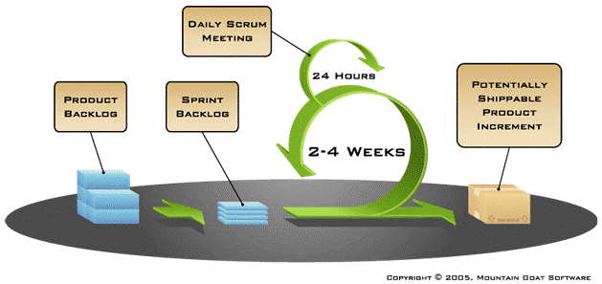
Fig 3.1: Scrum methodology process

Characteristics of Scrum
- Teams are self organizing in Scrum
- Scrum teams do a little of everything all the time rather than doing all of one thing at a time.
- Scrum are a series of two- to four-week “sprints”
- “Product backlog” is used to capture the requirements in Scrum
- No changes during the sprint are allowed

Product backlog and Sprints
Scrum is a series of “sprints”. Every sprint lasts for 30 days or at least 2-3 weeks. Sprint is more like iteration not in characteristics but from the timing perspective. All sprints in a scrum always have a constant duration. During the sprint a little of everything is done all the time rather than doing all of one thing at a time. The phases like planning, design, code, and testing are all done at a same time.

    - Justification for using scrum methodology
- Due to short sprints and constant feedback, it becomes easier to cope with changes.
- Regular meetings make it possible to measure individual productivity. This leads to the improvement in the productivity of each of the team members.
- The overhead cost in terms of process and management is minimal thus leading to a quicker, cheaper result.
- It is easier to deliver a quality product in a scheduled time.
- Another reason that Scrum methodology was because Ruby on Rails is agile in nature
- Agile scrum saves time and money.
- It is a lightly controlled method which insists on frequent updating of the progress in work through regular meetings. Thus there is clear visibility of the project development.

SYSTEM ANALYSIS

Gathering information is done to get information about the organizational and to deeply understand the topic and past research that have been done. Analysis phase mainly involves collecting data and analyzing the data.

4.1 Problem and Weaknesses of Current System
- Need of extra manual effort.
- It used to take much time to find any employee
- Not very much accurate.
- Danger of losing the files in some cases.

ADVANTAGES OF PROPOSED SYSTEM:
- Very fast and accurate.
- No need of any extra manual effort.
- No fever of data loss.
- Just need a little knowledge to operate the system.
- Doesn’t require any extra hardware device.

4.2. Feasibility Study
In this part the part the possibility of the project in the real world would be discussed. There are 3 feasibilities that should be analyzed; Technical feasibility, Economic feasibility, Schedule feasibility and Operational feasibility. The following were the outcome of the feasibility study:
(a) Technical Feasibility
Technical feasibility is referred to risks of the project with the requirement to maintain and implement the project. The main aim of this study was to find out the viability and practicability of undertaking this project. There was sufficient technology to enable every single requirement of this project to be met. Being a web (client-server) application, there was a number of technologies both for client-side and server-side programming. However, out of the numerous technologies available, Ruby On Rails and MySql was chosen for server-side logic and HTML/CSS/Javascript for client-side presentation.

(b) Economical Feasibility
The economic feasibility refer to an intangible benefit from new system that can be gain such as: more timely information, improved organizational planning, increased organizational flexibility, information processing efficiency, improved assert utilization and resource control. The cost of running this project to completion was affordable. From the cost/benefit analysis carried out, it was determined that the benefits of this new system out way costs by far.

(c) Schedule Feasibility
The schedule for the development of the system was attainable, largely contributed by the Scrum tools used in system implementation.

(d) Operational Feasibility
It is a standard that ensures interoperability without stifling competition and innovation among users, to the benefit of the public both in terms of cost and service quality.
The proposed system is acceptable to users. So the proposed system is operationally feasible.

4.3. Current Process
The current system is completely manual. When a customer comes for purchasing a book, he/she should find the book from the shelf and if he/she found it, take to cashier and pay for it. By developing this system for bookstore, I am sure all these problems will be solved. The current system is illustrated below as a conceptual diagram

4.4. User Requirements
The user requirements is discussing about functional requirements and non-functional requirements. Before that in Table 4.1 the existing system has been compared new system.
Weakness of the existing system | New system
- Purchasing and selling books by choosing through the shelves and manually. | - All processes done through the internet.
- Payment processing is done manually. | - Customer can pay through M-Pesa.
- Registering new customer is manually. | - All users can subscribe through the website online.
Table 4.1: Comparing old system to the new one

4.5. Functional Requirements
In functional requirements we consider some process such as creating the questionnaires and maintain items information. All factors are shown in Table 4.2.
Function | Project functional requirements
Functions | - The online bookstore system will need a database of basic information (about ISBN, Title, Description, and Price) about the books.  - Old operations such as to why to order the books will be asked in order to improve new system operation.  - Function which is going to add in the new system need to ask customers opinion in order to understand the whole process and how to make new system efficiency.
Table 4.2: Functional requirements for the project

4.6. Non -Functional Requirements
Non-functional requirements shows the system performance and behavioral such as operational requirements, performance requirements, and security requirements. These points are illustrated in Table 4.3
Functional | Non-functional requirements
Operation | - The system should have a database that can be access by all users.
Performance | - The system should be updated regularly.
Security | - Administrator has full privilege for ordering all kind of items.
Table 4.3: Non-functional requirements for the project

4.7. To-Be Process and Data Model
After reviewing the current manual system in the selected bookshops, a new system and structure is developed.
Functions for customers:
- New use account registration
- User login
- Book search
- Create an order
- Create and clear a shopping cart
- Download and upload free materials
All the activities and process that are involved in the proporsed system have been modeled using Use Case Diagram and Sequence diagram. Data that are involved in each process or activity is illustrated using Class Diagram.

4.7.1 Use Case Diagram
Use case is a description of a set of sequence of actions that a system performs that yields an observable result of value to a particular thing in a model. Graphically, Use Case is rendered as an ellipse with lines, usually including only its name as show below.

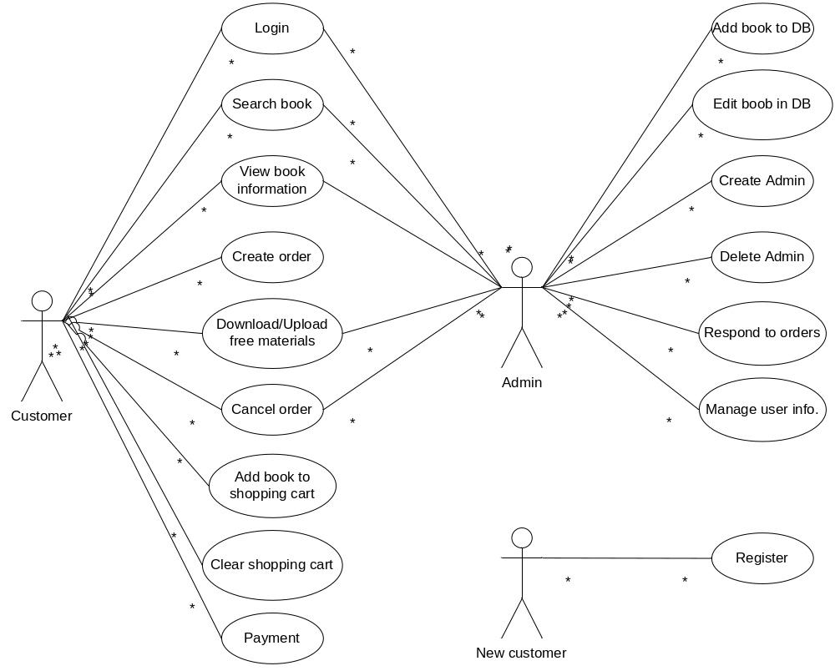

Fig 4.4: Use Case Diagram for the System

4.7.2 Class Diagram
Class diagrams are the most common diagrams found in modeling object-oriented systems. A class diagram shows a set of classes, interfaces, and collaborations and their relationships. Graphically, a class diagram is a collection of vertices and arcs.

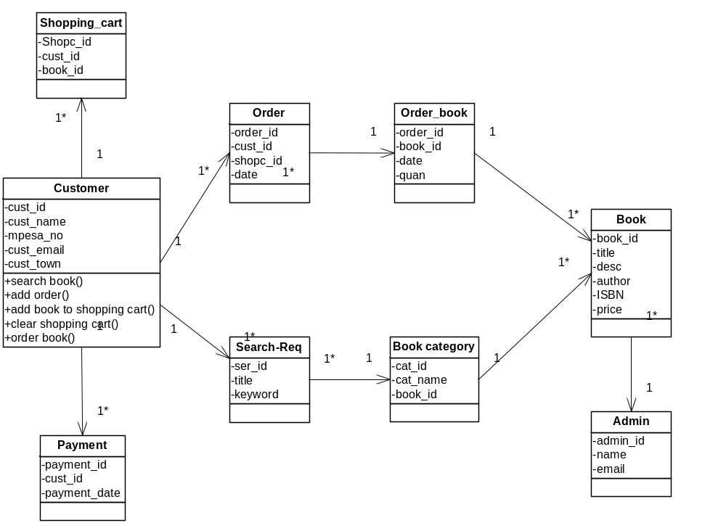
Fig 4.5: Class Diagram for the System

4.7.3 Sequence Diagram
Sequence diagram represent the classes that are involved in the system.
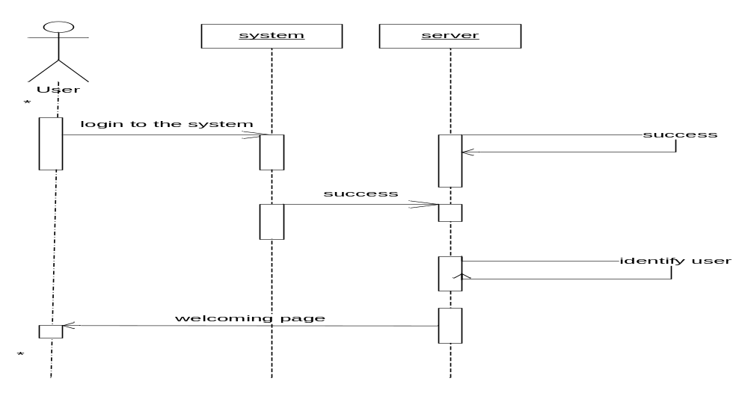
Fig 4.6: Login to the sequence diagram for the System
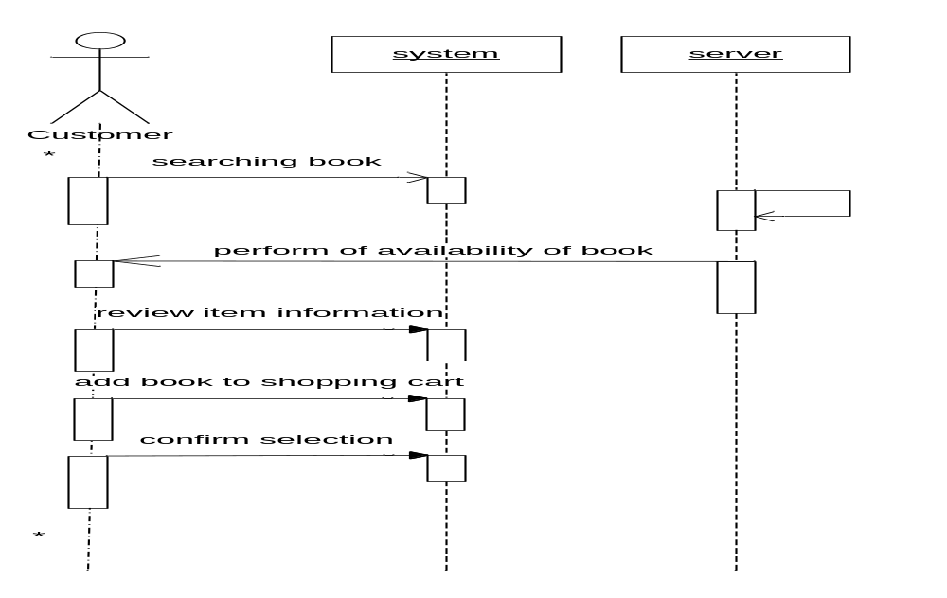

Fig 4.7: Order book sequence diagram for the System

SYSTEM DESIGN

In order to design a web site, the relational database must be designed first. Conceptual design can be divided into two parts: The data model and the process model. The data model focuses on what data should be stored in the database while the process model deals with how the data is processed. To put this in the context of the relational database, the data model is used to design the relational tables. The process model is used to design the queries that will access and perform operations on those tables.

5.1. Data Model
A data model is a conceptual representation of the data structures that are required by a database. The first step in designing a database is to develop an Entity-Relation Diagram (ERD). The ERD serves as a blue print from which a relational database maybe deduced. Figure 5.1 shows the ERD for the project and later we will show the transformation from ERD to the Relational model.

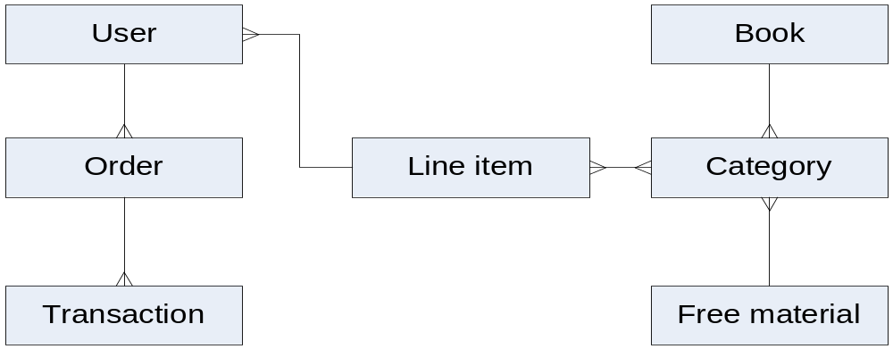
Fig 5.1: ERD for the System

5.2. Database Design
In this section, the basic structure of the tables composing the database for the project are shown long with information about primary and foreign keys.

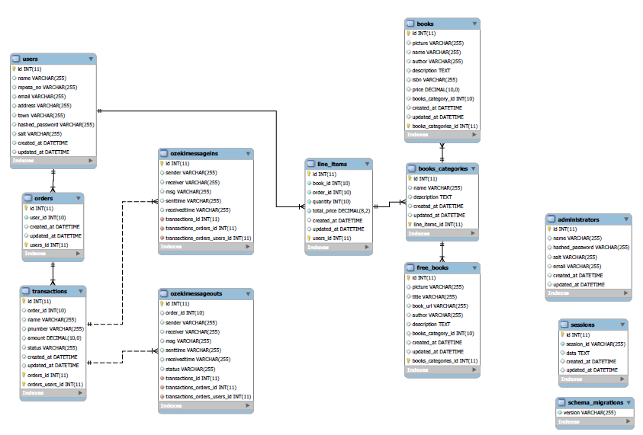

Fig 5.1: Database schema for the System

5.3. Process Model
A Process Model tells us about how the data is processed and how the data flows from one table to another to gather the required information. This model consists of the Functional Decomposition Diagram and Data Flow Diagram.

5.3.1 Data Flow Diagram

Data Flow Diagrams show the flow of data from external entities into the system, and from one process to another within the system.

Figure 11 are the Data Flow Diagrams for the current system. Each process within the system is first shown as a Context Level DFD and later as a Detailed DFD. The Context Level DFD (figure 10) provides a conceptual view of the process and its surrounding input, output and data stores. The Detailed DFD provides a more detailed and comprehensive view of the interaction among the sub-processes within the system.

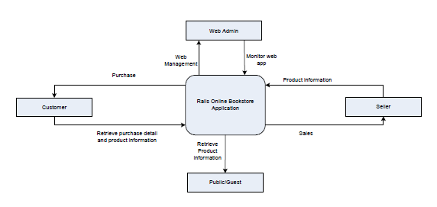
Fig 5.3: Context diagram for the System

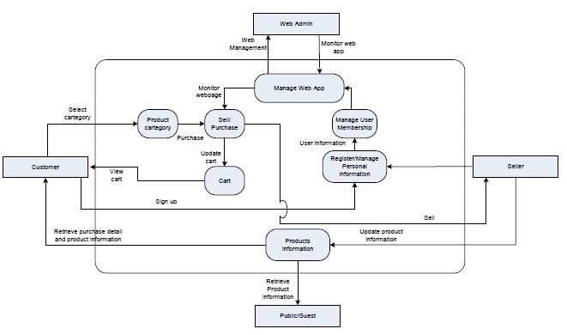
Fig 5.4: DFD diagram for the System

5.4. User Interface Design

Before implementing the actual design of the project, a few user interface designs were constructed to visualize the user interaction with the system as they browse for books, create a shopping cart and purchase books.

Fig 5.5: Menu
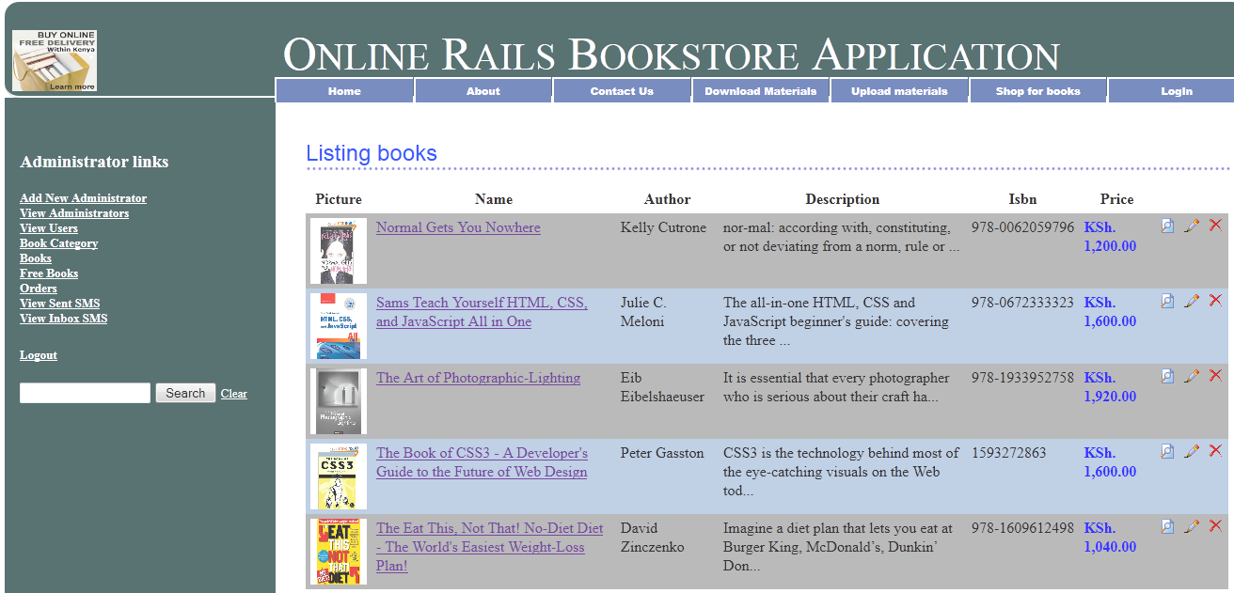

Fig 5.6: Display of books present in the store

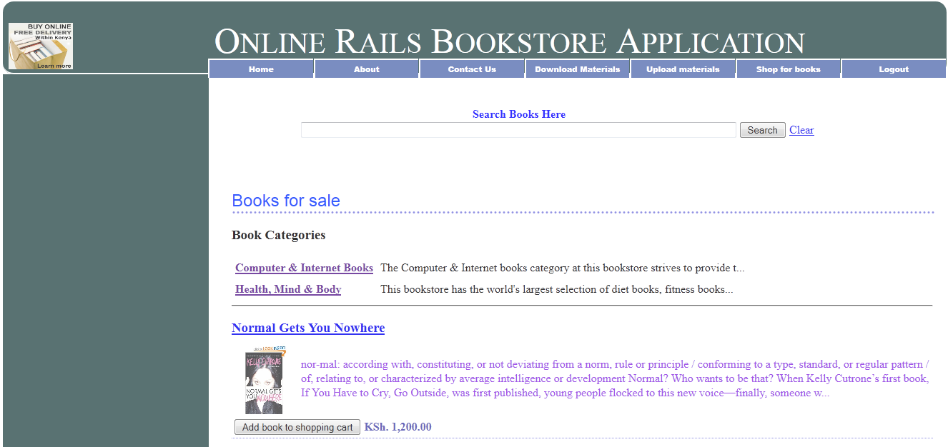

Fig 5.7: For searching the books in the store
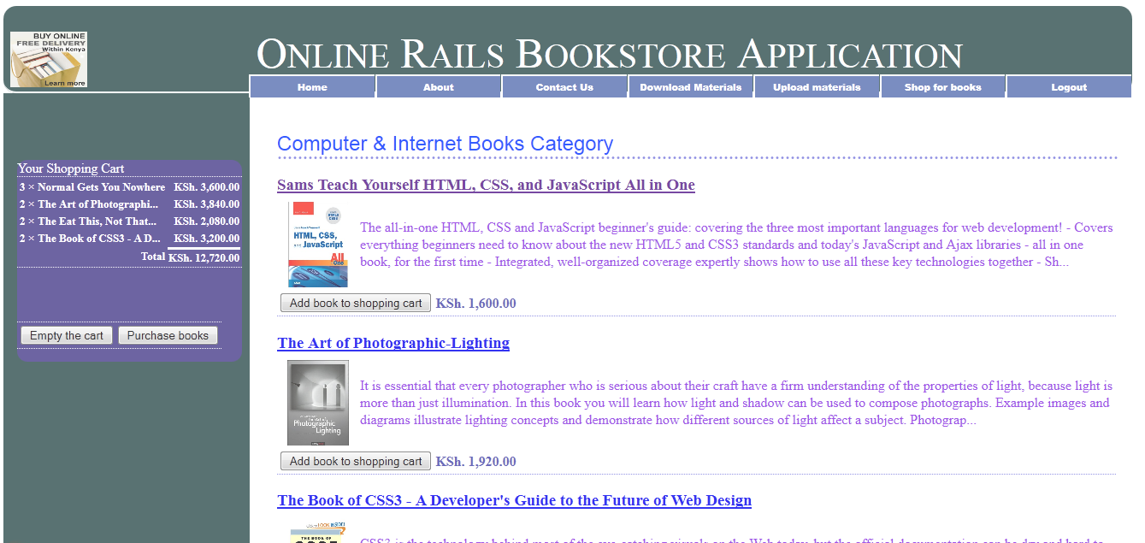

Fig 5.8: Shopping cart for the user

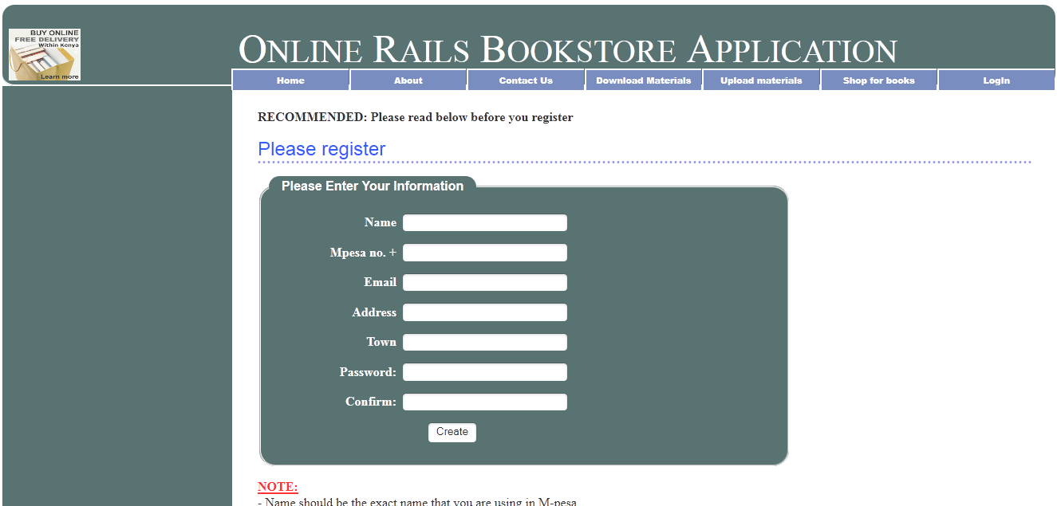

Fig 5.9: Registration of a new user

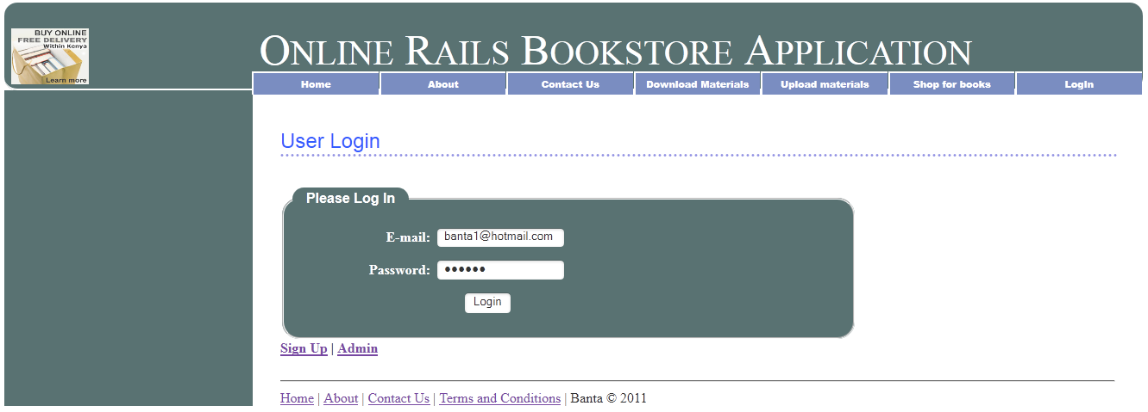
Fig 5.10: Authentication of the user

SYSTEM IMPLEMENTATION AND TESTING

6.1 Implementation Overview
The project was implemented as a web application with Ruby On Rails, MySQL and Ozeki SMS Server as the main technologies running the system logic.
(a) Implementation Overview
Since this project targets the masses, it was prudent that web be chosen as the platform for implementation since the Internet easily connects people all over the world.
(b) Choice of Technologies Used
Since the system was developed for the web platform, Ruby On Rails and MySQL were favorite for running the logic of the system for a couple of reasons.
Reasons for using Ruby on Rails
- It is powerful and simple
- Open-source
- Support integrated unit and functional testing support
- Support building out of new functionality incrementally
- Vast reduced code footprint
- Single-stack application framework
- AJAX UI support
- IDE automation not required
- Database agnosticism
- MVC separation of contents

However, other favorably competing technologies that would have been chosen in place of Ruby On Rails would be PHP, Python (Django), or JSP (JSF).

(c) Choice of Technologies Used
The MVC (Model View Controller) principle divides the work of an application into three separate but closely cooperated subsystems.
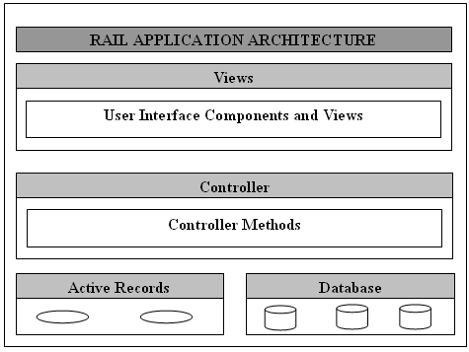
Fig 5.1: Representation of MVC framework

Model (ActiveRecord)
Maintains the relationship between object and database and handles validations, association, transactions, and more.
View (ActionView)
This is a presentation of data in a particular format (mostly HTML), triggered by a controller’s decision to present the data. They are script based templating and they are very easy to integrate with AJAX technology.
Controller (ActionController)
This is the facility within the application that directs traffic, on the one hand querying the models for specific data (searching, sorting, and massaging it) into a form that fits the needs of a given view.

6.2 Testing Plan
Any system, to be successful, must be thoroughly tested, and well managed test plan should be prepared before actual testing is being performed. “Modules” have been developed and need to be tested in a manner that can reduce occurring of defects as low as possible. Following are the activities we planned to test the system.

6.3 Testing Strategy
INTERFACE TESTING
Interface design model is reviewed to ensure that generic quality criteria established for all user interfaces have been achieved and that application specific interface design issue has been properly addressed.

Interface testing strategy: - The overall strategy for interface testing is to (1) Uncover error related to specific Interface mechanisms, WebApp functionality, or content display. To accomplish this strategy, a number of objectives must be achieved:

- Interface futures are tested to ensure that design rules, aesthetics and related visual content are available for the user without error.
- Individual interface mechanisms are tested in a manner that is analogous to unit testing For example; tests are designed to exercise all forms, client-side scripting.

Testing Interface Mechanisms:-
Forms: - At a microscopic level, tests are performed to ensure that
- Labels correctly identified fields within the form and that mandatory fields are identified visually for the user.
- The server receives all information content within the form and their no data are lost in the transmission between client and server.
- Appropriate defaults are used when the user does not select from a pull down menu or set of buttons.
- Browsing functions don’t corrupt data entered in the form.
- Scripts that perform error checking on data entered work.
- Properly and provide meaningful error message.

Client side scripting: - Black box tests are conducted to uncover any error in processing as the script is executed. These tests are coupled with forms testing because script input is often derived from data provided as part of forms processing

Dynamic XML: - Here the data transfer between the systems occurs in the form of xml file. The formatting of the XML file should remain unaltered. Changes in the internal attribute structure can also lead to an error. Hence for this XML parsing functionalities are provided on the client side.

Application specific interface mechanisms:-Test conforms to a checklist of functionality and features that are defined by the interface mechanism.

USABLITY TESTING: - Usability test may be designed by Project engineering team.
- Define a set of usability testing categories and identify goal for each.
- Design test that will enable each goal to be evaluated.
- Select participants who will conduct test.
- Instrument participant’s interaction with system while testing is conducted.
- Develop a mechanism for assessing the usability of the system.

The following test categories and objective illustrate establish testing:

Interactivity- Are interaction mechanism easy to understand and use?

Layout- Are navigation mechanism, content and function place in a manner that allows the user to find them quickly?

Readability- Is the text well written and clear?

Aesthetics- Do layout color, typeface, and related characteristics lead to ease of use?

Display Characteristics- Does the system make optimal use of screen size and resolution?

Time Sensitivity- Can important features, functions and content be used in a timely manner?

Accessibility- Is the system accessible to people who have Disabilities?

COMPATIBILITY TESTING:-
Project must operate within environment that differs from one another. Different computer, display device, OS, browser and network connection speed can have significant on system operation. The Project team derives a series of compatibility, validation tests, derived from existing interface tests, navigation tests, performance tests and security tests.

6.4 Testing Methods
Analyze and check system representation such as the requirement document, design diagrams and the program source code. They may be applied at all stages of the process.
A test-driven development approach was used and the main objectives of testing were.
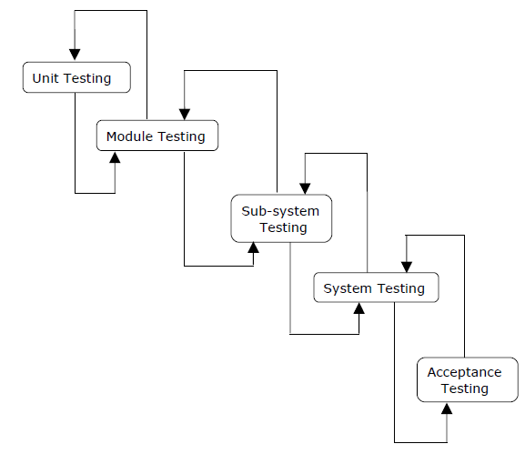
Fig 6.1: Test method used
There are different Models of testing. On the basis of testing methods there are two types of testing:

1. White-box testing.
2. Black-box testing

1). WHITE-BOX TESTING

White-box testing sometimes called glass-box testing, is a test case design method that users the control structure of the procedural design to drive the test case.
- Logical errors and incorrect assumption are inversely proportional to the probability that a program will be executed. Errors tend to creep into our work we design and implement function, condition or control that is out of the mainstream tends to be well understood.
- We often believe that a logical path is not likely to be executed when in fact it may be executed on a regular basis. The logical flow of a program times counter intuitive.

2). BLACK-BOX TESTING:

For our project periodically we have tested our software using black-box testing. Thinking as a client we have evaluated the software for its easy going and convenience.

Unit Testing:
During the programming stages each and every form, modules and class treated unit has been put into the test data. Every module is tested independently. The steps are follows:

- Manually code is tested like spelling checks, logic and errors.
- Once the manual checking is over the complication has been done. Syntactical errors if any have to be corrected.
- After the clean complication the program, some dummy data, as specification, has been used for testing of the module to see if it works as specified.

Integration Testing
After our individual’s modules were tested out we go the integrated to create a complete system. This integration process involves building the system and testing the resultant system for problems that arise from component interaction.

Performance Testing
Performance testing is designed to test the runtime performance of the system within the context of the system. These tests were performed as module level as well as system level. Individual modules were tested for required performance.

Condition Testing
Performance testing is a test case design method that exercises the logical conditions.

Interface Testing
Interface sting is integral part of integration. We examined the code to be tested and explicitly list each call to an external component. In the system standards tests for GUIs have been performed, which are as follows:
  - The position and related labels for all controls were checked.
  - Validations for all inputs were done.
  - Pull down controls was verified for proper functionality.
  - Whether the non-editable text controls disabling and it was also verified that it doesn’t exceed the maximum allowed length.

6.5 Test Environment
The system was tested on both a development environment and a real-world (production) environment.

6.5.1 Development Environment
- Architecture: Pentium® Dual-Core CPU T4300 @ 2.10GHz, 2.10 GHz
- Memory (RAM): 2.00GB
- Operating System: Windows 7 64-bit
- Language: Ruby On Rails
- Web Server: Webrick
- Database Server: MySQL 5
- IDE: Netbeans IDE 6
- Browsers: Firefox 4 and IE 9

CONCLUSION

- Shopping at an online bookstore provides customers the ultimate individual experience. Anyone can buy books tailored to his unique interests while relaxing in sweatpants on the couch. These businesses are changing the way authors and readers come together and will impact the publishing and retail industries in the future.

- There are many booksellers to choose from online in every city across the world with varying amounts of titles. Finding the right online bookstore is easy, so test them out the next time you are in the market for books. It is possible to find discounted titles, coupons or promotions for deals along with specials for additional discounts on online bookstores as well so make sure to look for those before you make your next purchase.

- You will find that online stores range in size, and will carry every kind of book that you are interested in buying. If one online book store does not have what you want, then you will be sure to find another online book store that does. Online bookstores cater to the needs of individuals who need items delivered to them for convenience. It is possible to buy books online and have your order waiting for you at a local bookstore chain, if you order from their particular website and/ or call their customer service.

- Since there are several major online bookstores, these businesses are aware of the customer's ability to comparison-shop online, and are therefore competitive in pricing books. Some offer deep discounts for new releases while others offer free shipping if a customer's order totals over a certain dollar amount. This benefits the consumer, who can find the best deal for his needs with a few clicks on the Web, rather than driving from bookstore to bookstore to compare prices.

7.1 Summary of Results and achievement
In summary, all the stipulated requirements were met by the system exactly as it was outlined the in the requirements document.

At the end of the project, the significant achievement was a wealth of experience in web development especially in the use of frameworks that help in focusing on solving a problem than worrying on the programming bit of the solving problem. Also there was a significant achievement in learning how to design better, especially with the problem domain in mind and tradeoffs between simplicity, extensibility and performance.

7.2 Constraints and Challenges
Time was one of the major constraints in this project. Even though the schedule was met, but given more time there were lots of other improvements and inclusions to be made.
This system is stand alone system so data saved during different processes are stored in the machine in which that process was executed. So there is the problem of distributed database.

7.3 Suggestions for Further Works
The following are the suggestions for further works, which perhaps will be included in the end product of this project to be launched as http://www.Banta.co.ke/bs
- Addition of explicit social layer on the system e.g forums
- Integration with Amazon and other websites
- A fully compliant mobile web version of the system
- Communication companies API in Kenya for SMS handling
- Mobile money till number
- Bookshop module

APENDICES

APENDIX A: Sample code
  - Order processing code
def sms_in
@transaction = Transaction.new(params[:transaction])
@cart = find_cart
$i = 1;
$num = Ozekimessagein.last.id;
$uid = User.find(session[:user_id]).id
until $i > $num do
$fr = Ozekimessagein.find($i).sender
$msg = Ozekimessagein.find($i).msg
$name = User.find(session[:user_id]).name.upcase
$m_no = "#{User.find(session[:user_id]).mpesa_no}"

if $fr == "D48617A140"
$ksh = $msg.split(" ")[5][3,$msg.split(" ")[5].size].delete(",").to_i #split, 5th element,remove "Ksh", remove ",", change to integer
else
$ksh = 0
end
if $fr == "D48617A140" and $msg.include?("#{$name}") and $msg.include?("#{$m_no}") and $ksh >= $gt and (Ozekimessagein.find($i).senttime.to_datetime) > (Time.now - 172800)
@transaction.order_id = Order.last.id
@transaction.name = User.find(session[:user_id]).name
@transaction.pnumber = User.find(session[:user_id]).mpesa_no
@transaction.amount = $gt
@transaction.status = "Processed"
if @transaction.save
@ozekimessageout = Ozekimessageout.new(params[:ozekimessageout])
@ozekimessageout.order_id = Order.last.id + 1
@ozekimessageout.sender = "+254713973902"
@ozekimessageout.receiver = "+#{User.find(session[:user_id]).mpesa_no}"
$tw = User.find(session[:user_id]).town
@ozekimessageout.msg = "Thank you #{User.find(session[:user_id]).name} for your purchase. Your books will be delivered to #{$tw} on #{Time.now + 3.days}. More info. Banta.co.ke/bs"
$tm = Time.now
@ozekimessageout.receivedtime = $tm
@ozekimessageout.status = "send"
if @ozekimessageout.save
flash[:notice] = "Thank You. You'll receive an sms to notify you when the your books will be delivered"
$i = $num + 1;
puts "denis"
end
end
else
puts "grep"
if $i == $num
@transaction.order_id = Order.last.id
@transaction.name = User.find(session[:user_id]).name
@transaction.pnumber = User.find(session[:user_id]).mpesa_no
@transaction.amount = $gt
@transaction.status = "Canceled"
if @transaction.save
flash[:notice] = "Transaction canceled"
@ozekimessageout = Ozekimessageout.new(params[:ozekimessageout])
@ozekimessageout.order_id = Order.last.id + 1
@ozekimessageout.sender = "+254713973902"
@ozekimessageout.receiver = "+#{User.find(session[:user_id]).mpesa_no}"
@ozekimessageout.msg = "Thank you #{User.find(session[:user_id]).name}. Your transaction has been canceled. Please login to purchase. More info. Banta.co.ke/bs"
$tm = Time.now
@ozekimessageout.receivedtime = $tm
@ozekimessageout.status = "send"

if @ozekimessageout.save
flash[:notice] = "Your transaction was canceled. You'll receive an sms to notify you."
end
end
end
end
$i = $i + 1;
end
redirect_to :controller => :home, :action => :index
end

def cancel_trans
@transaction = Transaction.new(params[:transaction])
@transaction.order_id = Order.last.id
@transaction.name = User.find(session[:user_id]).name
@transaction.pnumber = User.find(session[:user_id]).mpesa_no
@transaction.amount = $gt
@transaction.status = "Canceled"
if @transaction.save
@ozekimessageout = Ozekimessageout.new(params[:ozekimessageout])
@ozekimessageout.order_id = Order.last.id + 1
@ozekimessageout.sender = "+254713973902"
@ozekimessageout.receiver = "+#{User.find(session[:user_id]).mpesa_no}"
@ozekimessageout.msg = "Thank you #{User.find(session[:user_id]).name}. Your transaction has been canceled. Please login to purchase. More info. Banta.co.ke/bs"
$tm = Time.now
@ozekimessageout.receivedtime = $tm
@ozekimessageout.status = "send"

if @ozekimessageout.save
flash[:notice] = "Your transaction was canceled. You'll receive an sms to notify you."
redirect_to :controller => :home, :action => :index
end
end
end

private
def counter
$j = 0;
$m = 30;

while $j < $m do
sleep(1)
puts("Inside the loop i = #$j" );
$j +=1;
end
end

APENDIX B: User manual
Installation manual
- Install Netbeans IDE 6 and above
- Install Ruby plug in the Netbeans IDE
- Set up the database
- Open the project folder from Netbeans IDE as a main project
- Run the project

APENDIX C: References

Articles
- ¹Diwakar, H., Marathe, M. (2000). The architecture of a one-stop web-window shop. December, ACM SIGecom Exchanges, Volume 2 Issue 1.
Books
- Fundamentals of Software Engineering By Rajib Mall
- Software Engineering By Ian Somerville
- Analysis and Design of Information Systems By James Senn
- ²Wiley, Y. M. J. & Sons. (1997) Creating the Virtual Store: Taking Your Web Site from Browsing to Buying.
Websites
- Guides and tutorials, http://www.guides.rubyonrails.org
- http://www.google.com
- http://www.ask.com
- Netbeans IDE software download, http://www.netbeans.org/downloads
- Ruby On Rails software download, http://www.rubysourseforge.org/
- http://www.x-cart.com/articles/design_development.html for online customer behavior.
- http://www.agilemodeling.com/artifacts/dataFlowDiagram.htm for definition of Data Flow Diagram.

